

**Cohort 8 Group Members and Roles**

1. Hansel Omondi -Project Lead

2. Kristian Onjala

3. Prince Mwangi

Mentor: Gladys Kanyora

# **ViaziLink**

# **Problem Background**

According to a 2023 World Bank report, over 70% of rural residents across Africa depend on agriculture as a source of livelihood. Potato farming is the second most important crop in Kenya, after maize, and contributes over Ksh 50 billion to the economy as well as employing over 3.5 million people within the potato value chain.

Middlemen control direct market access and the majority of the transactions, contributing to potato farmers not being able to generate earnings that are commensurate to their work. A 2023 report by KARI shows that potato farmers earn sometimes up to 30% less than the expected market share which is about Ksh.2500/bag. Small-scale potato farmers are the most affected. Logistical barriers that make transportation expensive as well as the organizational structures at local market centers that do not allow farmers to sell directly, have contributed to their reliance on middlemen.

Addressing these challenges is crucial for empowering farmers, improving their incomes and stimulating economic growth in rural areas across Kenya and Africa.

Related Solutions Include;

1. **Potato Farmers' Cooperatives**: Several cooperatives, such as the Kenya Potato Growers and Processors Association (KPGPA), have been established to support potato farmers. These cooperatives aim to pool resources, improve bargaining power, and facilitate better access to markets. However, while cooperatives can offer collective bargaining benefits, they often struggle with logistical constraints and have limited reach, particularly among small-scale farmers who may not have the means or resources to join these groups.
2. **Digital Platforms**: Initiatives like **Twiga Foods**, **Green Spoon** and **Tawi** have developed digital platforms that connect farmers with buyers, including retailers and wholesalers. Twiga Foods, for example, provides a platform that aggregates produce from farmers and delivers it to urban markets. Although these platforms have improved market access for some farmers, they primarily target larger-scale producers or those in specific regions, leaving many smallholder farmers, especially in remote areas, underserved.
3. **Agricultural Extension Services**: Government programs and NGOs often run extension services to offer advice on farming techniques, market prices, and crop management. For instance, the **National Potato Council of Kenya (NPCK)** works to improve production techniques and provide market information. While these services can enhance farmers' knowledge and productivity, they cannot frequently address the immediate logistical issues or offer practical solutions for small-scale farmers facing exploitation.
4. **Mobile Payment Solutions**: Mobile money platforms like M-Pesa have been integrated into agricultural transactions to improve financial inclusion and transparency. Farmers can receive payments directly to their phones, which can reduce cash-handling risks and increase transparency. However, these solutions do not inherently address the logistical challenges or the power dynamics between farmers and middlemen, which remain significant barriers to fair pricing.
5. **Market Information Systems**: Projects such as **Agri-Sok** have been developed to provide farmers with real-time market prices and demand information via SMS or mobile apps. These systems aim to empower farmers with data to negotiate better prices. Despite this, the effectiveness of such systems is limited by factors like inconsistent internet access, low digital literacy among farmers, and the challenge of translating information into actionable negotiation strategies.

Our project seeks to **bridge these gaps** by developing a comprehensive platform that connects farmers directly with buyers, leveraging technology to provide real-time market information, transparent pricing, and logistical support. This platform aims to empower farmers with the tools and knowledge necessary to negotiate better prices and reduce their reliance on exploitative middlemen.

To address this problem effectively, our project will focus on several research questions:

* How can we design a technology platform that effectively connects farmers with buyers while providing transparent and fair pricing?
* What logistical solutions can be integrated into the platform to minimize delays and ensure timely delivery of perishable goods?
* How can we ensure that the platform is accessible to the majority of small-scale potato farmers and meets their specific needs?

# **Market Opportunity**

# **Solution Idea**

# This section should contain the following subsections:

* Our primary target users are smallholder potato farmers in Nyandarua. They were identified through interviews and consultations with agricultural experts and community leaders. This group is chosen due to their direct experience with market exploitation and the potential for significant improvement in their livelihoods through better market access.
* While other stakeholders, such as consumers in Nairobi and retailers, are also part of the ecosystem, our focus on farmers addresses the root issue of income instability caused by middlemen.

***Solution Prototype***

We propose developing a mobile application that directly connects potato farmers in Nyandarua with consumers and retailers in Nairobi. Key features of the app will include:

* **Market Price Alerts:** Providing real-time updates on potato prices in Nairobi to inform farmers about market trends.
* **Logistics Coordination:** Partnering with local transport services to facilitate the timely delivery of produce to Nairobi.
* **Direct Sales Channels:** Enabling farmers to list their produce for sale, allowing consumers to order directly from them.

The user journey will begin with farmers registering on the app, entering their produce details, and setting prices based on market insights. Consumers in Nairobi can then browse available products, place orders, and arrange for delivery. This direct connection aims to eliminate the middleman, ensuring fair prices for farmers.

*Assumptions Made*

When designing ViaziLink there were some assumptions made which include:

1. The Small scale farmers have access to devices that have internet access
2. The Small scale farmers will adopt the technology that will improve their sales
3. Market conditions will allow for direct sales to the consumers with little reliability on middlemen
4. ViaziLink will effectively address logistical issues in rural areas

# **Value proposition**

Our solution seeks to empower potato farmers in Nyandarua by providing them with a digital platform that enhances their market access, ensuring fair prices and supporting rural economic development. Ultimately increasing their income and economic stability.

# 

# **Designed Solution**

*Technologies Used*

Kotlin - Used to develop the Android application including its user interface and the backend features.

*Screenshots of Main Modules*

##### Login and SignUp Screens

These screens will enable a farmer to log in to the app and register an account on the platform, respectively.

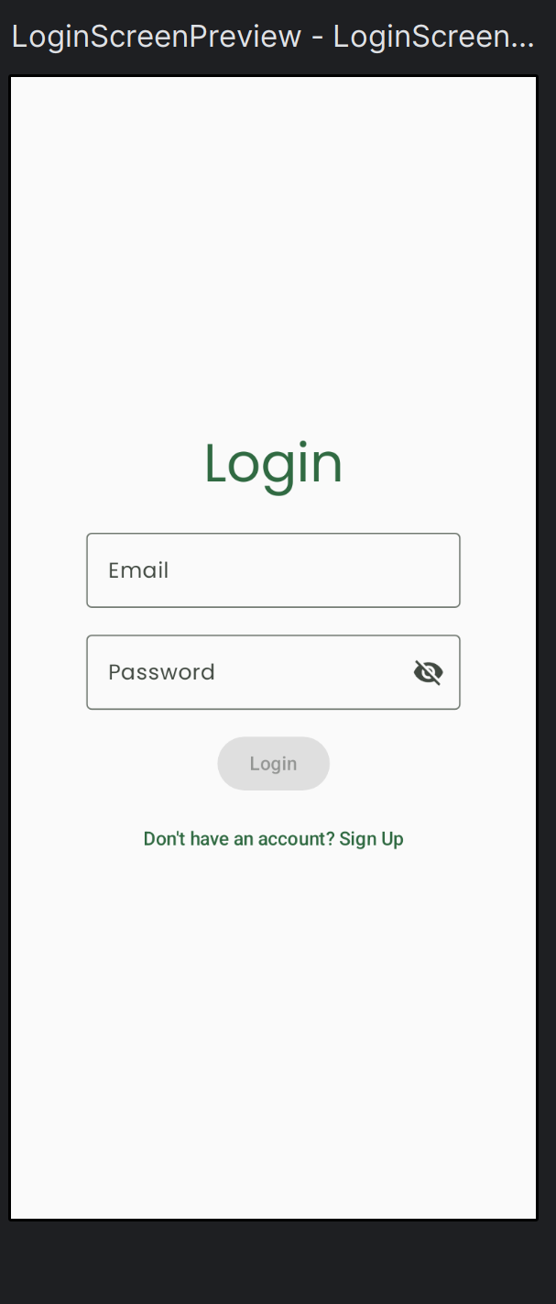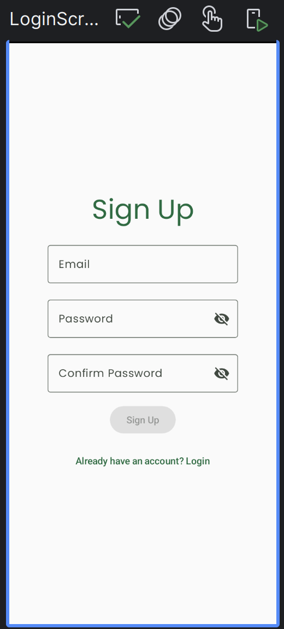

##### Home Page

On this screen, a farmer will be able to view a list of orders that have been placed by customers.



##### Listings Page

On this page, a farmer will be able to view a record of the produce listings they have posted on the platform.



##### Add Listing Page

On this page, a farmer will be able to post a new listing of their produce on the platform. They will include all the details of their produce.

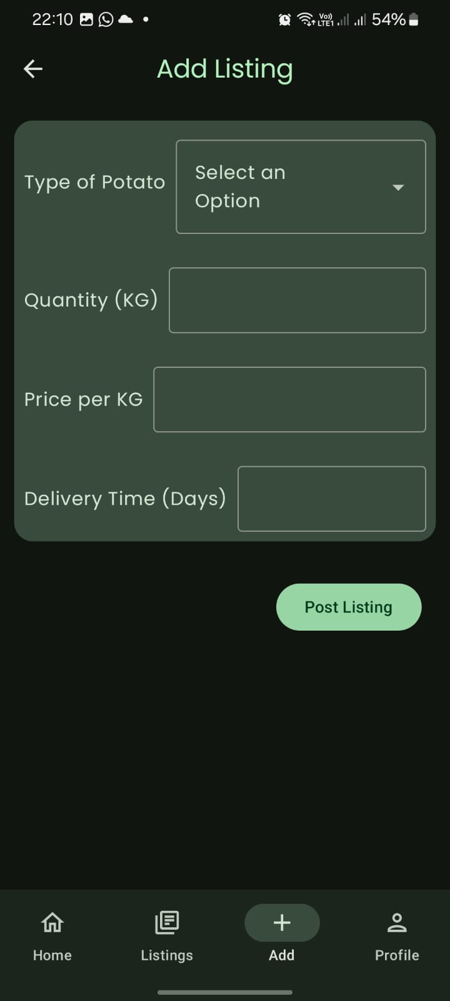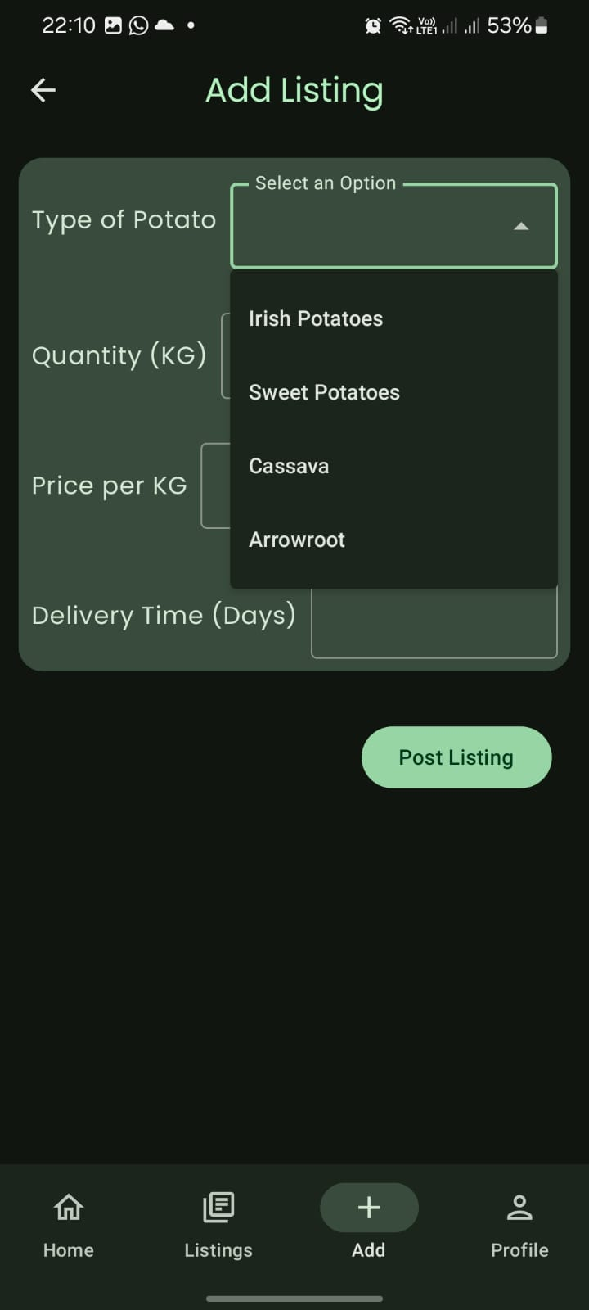

*Link to the solution*

<https://github.com/kamilimumobile/viazilink>

# **Business Model**

**REVENUE GENERATION**

**Commission Structure**

Currently, farmers often receive low prices for their produce due to high transportation costs and the influence of middlemen. Middlemen typically buy produce at a significantly reduced price to cover their own expenses, which leads to farmers earning less. The end consumers end up paying inflated prices due to the added costs from middlemen and transportation.

**The solution**

We propose a direct model where we take a percentage (30%) of the sale price of the produce, which allows for better financial outcomes for both farmers and consumers.

By taking a 30% commission on the sale price of the produce, you establish a clear revenue stream. For example, on a Ksh. 5000 sale, you would earn Ksh. 1500, while the farmer receives Ksh. 3500. Not only does this model allow for profit generation but also ensures that farmers are motivated to participate.

**Non-Profit**

**Partnerships:** Collaborations with government agencies, NGOs, and private companies can provide financial support or in-kind contributions.

**Donations:** Donations from individuals, corporations, and foundations can provide financial support.

**Corporate Sponsorships**: Partner with companies interested in social responsibility initiatives to secure funding in exchange for visibility and branding opportunities.

We shall ensure financial stability by;

1. Regularly assessing and reporting on the impact of the initiatives to attract continued funding and demonstrate effectiveness to potential donors.
2. Having strategic partnerships with organizations that share the platform's goals can provide financial support, resources, and market access.
3. Careful management of operating costs, including technology infrastructure, personnel, and marketing expenses, will be crucial.

# **Responsible Computing**

**Accessibility**: The platform will include features specifically designed for users with visual impairments, such as voice navigation and screen reader compatibility. This inclusivity ensures that all farmers, regardless of their abilities, can access market information and participate in the platform.

**User Privacy and Data Security**: Protecting user data is paramount. We will implement robust security measures, including encryption and secure login protocols, to safeguard personal information. Users will also be made aware of what data is being collected on the platform and how it will be used.

# 

# **Traction**

When conducting our problem identification and requirements elicitation, we spoke to two potato farmers in Nyandarua; Mrs Rimui and Eunice. We have conducted QA testing on the app, in development, mimicking different user flows and scenarios within the test cases. These tests were to ensure the robustness of the application. At the moment, we are currently, in the early stages of user engagement and have not yet made any money from selling it. Thus there is no recorded impact as of yet.

# **Funding/Support Need**

1. **Technology Development (Ksh. 15,000,000):  
   Platform Infrastructure:** Building a robust and scalable platform to handle large volumes of data and transactions.

**User Interface (UI) and User Experience (UX) Design:** Creating an intuitive and user-friendly interface for both farmers and consumers.

**Mobile App Development:** Developing a high-quality mobile app for Android devices, compatible with most smartphones used by Kenyan farmers.

**Integration with Payment Gateways:** Integrating with popular Kenyan mobile money platforms like M-Pesa and Airtel Money to facilitate secure and convenient transactions.

1. **App Development (Ksh. 8,000,000):  
   Features:** Developing features such as real-time market price updates, order tracking, logistics coordination, and secure messaging.

**Testing and Quality Assurance:** Rigorously testing the app on various devices and networks to ensure a seamless user experience.

**App Store Optimization:** Optimizing the app for visibility on the Google Play Store and Apple App Store to reach a wider audience of farmers and consumers.

1. **Server Costs and Infrastructure (Ksh. 3,000,000):  
   Hosting:** Renting a reliable server or cloud-based infrastructure to host the platform and ensure uninterrupted access.

**Data Storage:** Providing sufficient storage capacity for user data, product listings, and transaction history.

**Network Connectivity:** Ensuring high-speed internet connectivity to support real-time data transfer and communication.

1. **Marketing and Outreach (Ksh. 2,000,000):  
   Digital Marketing:** Utilizing social media, online advertising, and content marketing to reach target audiences in rural and urban areas.

**Public Relations:** Engaging with local media to raise awareness and generate positive publicity.

1. **Partnerships and Collaborations (Ksh. 1,000,000):**

**Transport Providers:** Partnering with local transport companies or cooperatives to facilitate efficient and affordable delivery of produce.

**Government Agencies:** Collaborating with the Ministry of Agriculture, Livestock, and Fisheries to leverage their resources and expertise.

**Financial Institutions:** Partnering with banks or microfinance institutions to provide financial services to farmers.

1. **Operational Expenses (Ksh. 5,000,000):  
   Salaries and Wages:** Paying salaries to employees responsible for platform development, maintenance, marketing, and customer support.

**Office Rent and Utilities:** Renting office space and covering expenses such as electricity, internet, and office supplies.

**Legal and Accounting Fees:** Hiring legal and accounting professionals to ensure compliance with regulations and manage financial records.

1. **Contingency**

# 

# **Your team**



**Hansel Omondi** serves as the Project Lead, bringing strong leadership skills and also plays a key role in the technical development of the app. His ability to coordinate team efforts and ensure timely execution of tasks is crucial for driving the project forward.



**Kristian Onjala** contributes technical expertise, particularly in mobile application design and user experience. His proficiency in Kotlin and experience with building user-friendly interfaces will be essential in developing a seamless app for farmers.



**Prince Gichere** conducts research to gather insights about farmers' needs and preferences, helping to shape the app’s features and ensure it meets user expectations.

Together, we are committed to developing a platform that empowers potato farmers and enhances their market access.